WRITE, IMPRINT OR ATTACH LABEL

Surname

First names Sex

DOB

Location Home -


Assessment Chart for Wound Management

For multiple wounds complete formal wound assessment for each wound. Add Inserts as needed.

Factors which could delay healing:
(Please tick relevant box)
Immobility □ Poor Nutrition □ Diabetes □ Incontinence □

Respiratory/Circulatory Anaemia □ Medication □ Wound Infection □
Disease □

Inotropes □ Anti-Coagulants □ Oedema □ Steroids □

Chemotherapy □ Other………………… Allergies & Sensitivities………………………

Body Diagram  Front Back  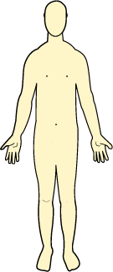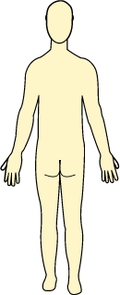  Mark location with ‘X’ and number each wound  Type of Wound Total number & duration  of each type of wound  Leg Ulcer x 2 as a result of skin tear from dog  Surgical Wound ……………………………….  Diabetic Ulcer ………………………….…  Pressure Ulcer ………………………………..  Other, specify ……………………………… | Feet Diagram  Right Left  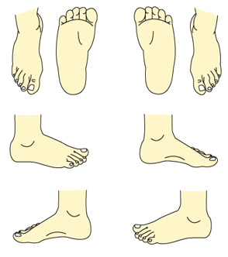  Mark location with ‘X’ and number each wound  Date referred to:  TVN ………….  Podiatrist………………...  Other (please specify)………………………….  Assessors signature: ………………………..  Date: ………………………..…………………...
Formal Wound Assessment
Complete on initial assessment and thereafter complete at every dressing change
Date of Assessment
Number of wound
Analgesia required  (Refer to local pain assessment tool) | Yes/No |  | Yes/No | Yes/No | Yes/No | Yes/No | Yes/No | Yes/No | Yes/No
Regular/ongoing analgesia
Pre-dressing only
Wound Dimensions (enter size)
Length (cm/mm)
Width (cm/mm)
Depth (cm/mm)
Or trace wound circumference
Is wound tracking/undermining
Photography
Tissue type on wound bed ( enter percentages)
Necrotic (Black)
Sloughy (Yellow/Green)
Granulating (Red)
Epithelialising (Pink)
Hypergranulating (Red)
Haematoma
Bone/tendon
Wound exudate levels/ type (tick all relevant boxes)
Low
Moderate
High *
Serous (Straw)
Haemoserous (Red/Straw)
Purulent (Green/Brown/Yellow)*
Peri-wound skin (tick relevant boxes)
Macerated (White)
Oedematous *
Erythema (Red)*
Excoriated (Red)
Fragile
Dry/scaly
Healthy/intact
Signs of Infection * 1 or more of these signs may indicate possible infection
Heat *
New slough/necrosis(deteriorating wound bed)*
Increasing pain*
Increasing exudate*
Increasing odour*
Friable granulation tissue*
Treatment objectives (tick relevant box)
Debridement
Absorption
Hydration
Protection
Palliative / conservative
Reduce bacterial load
Assessors Print Initials
Dressing Renewed (planned or unplanned dressing change)
Re-assessment date

Wound Treatment Plan and Evaluation of Care

To be completed when treatment or dressing type / regime altered
NB Please write clearly

Date | Wound Number | Cleansing Method, Dressing Choice & Rationale | Frequency | Evaluation & Rationale for changing dressing type | Signature

